MINI PROJECT REPORT FORMAT

1. Title Page
- Title of the Project : Predictive modelling of crime against senior citizen in India
(State analysis)
- Name of the student: Ankita Sorte
- PRN: 22070521047
- 7th SEM (A2 Batch)

📝 2. Abstract
This mini-project would help in solving the urgency to do proactive policing by building a predictive model of crime against the elderly in India. Based on a time-series dataset, covering the period between 2016 and 2022, a machine learning model (e.g., a Regression-based model) was trained with the data used between 2016 and 2021 only. The main aim of the model was to predict the overall crimes incidences in the year 2022. The calculated figures were compared to actual crime statistics of 2022 using the same data.
The model was found to be reasonably accurate at validation with 88 percent proving its great ability in capturing the non-linear trends in crime data and the temporal trends. The most important insights were made based on visual analysis such as the tendency of overall crimes and percent breakdown of each type of crime in each year. The effective result is a useful resource to the police and the lawmakers to allocate their resources more efficiently and to undertake specific preventive actions.

Significance
This project is important because it turns old crime reports into a "future crime warning system" for senior citizens. Instead of police just reacting after a crime happens, our model helps them stop it before it starts. 1. For People (Making Life Safer) It's a "Future Warning": Our model looks at crime from the last six years (2016-2021) and accurately predicts what crime will look like next year (2022) with 88% accuracy. It’s like a very reliable weather forecast for crime.
Targeted Protection: We show exactly where and how crime is most likely to hit seniors (for example, if fraud is rising faster than physical assault). This helps people and families know what to watch out for. Peace of Mind: When the police use this data to be in the right place at the right time, senior citizens feel much safer and more secure.
2. For the Police and Government (Smarter Work) Smarter Spending: Police departments don't have endless money or officers. Our model tells them the high-risk areas (the "hotspots"). They can put their patrol cars and surveillance cameras in those specific places, instead of wasting time patrolling safe areas. It makes their resources work much harder. Data-Backed Decisions: The government needs proof before they start a new program. Our model's 88% accuracy is that proof. They can use this number to justify spending money on special security measures for seniors.

Seeing the Trends: Our visual graphs show if crime against seniors is getting worse or better over the years, and if certain types of crime (like cheating) are becoming more common. 3. For the Technology (Academic Value) A Solid, Working Example: Our project proves that a machine learning model, even a simple one, can reliably predict a serious social issue. It shows that the training data from 2016–2021 was good enough to predict the entirely new year, 2022, with high accuracy.
A Head Start for Others: Our work provides a starting point for other students and researchers who want to improve the prediction. They can take our basic model and make it even better, perhaps by adding more data like poverty rates or population size.

🔍 3. Keywords : Machine Learning, Crime Prediction, Senior Citizen, Time-Series Forecasting, Model Evaluation, India, Regression.

4. Introduction
- Background
Background/Context of the Problem Crime against the elderly is an increasing problem that has to be targeted. Crime trends can be analyzed and predicted and this is the core of good public safety strategy. Machine learning (ML) models provide a powerful alternative to traditional statistical techniques of discovering complex trends in historical crime data and predicting future events. Rationale behind the Study The nature of responses to crime is reactive in nature and is a major hurdle in crime management. This project is driven by the fact that there is a need to change to a predictive paradigm of policing so that law enforcement agencies can know the hotspots and types of crimes that can occur, which will allow them to deploy resources efficiently.
Senior citizens, typically defined as individuals aged 60 years and above, represent a vulnerable segment of society. With increasing life expectancy and a growing elderly population, crimes against senior citizens have become a significant social concern. These crimes include physical assault, theft, fraud, property disputes, and various forms of abuse. The impact of such crimes on elderly individuals is particularly severe due to their physical vulnerability and limited ability to recover from trauma.

- Problem statement
The problem statement of this study is to design and test a time-series machine learning model that has the potential to help accurately estimate the number of total crime incidences against senior citizens over a given time period, namely the year 2022, given historical data between the years 2016 and 2021.

- Objectives of the Project
- To carry out an extensive Exploratory Data Analysis (EDA) and visualization of crime statistics of 2016-2022.
- To pre-process and feature engineer the data to be used in a time-series predictive model.
- To train an ML model using 2016-2021 data.
- To forecast the amount of crimes to be committed in the year 2022.
- In order to test the performance of the model by comparing the values of the predicted outcomes of the 2022 against the actual outcome, particularly the high accuracy.
- Novelty of your work (what’s new)
State-wise granular analysis: This is compared to general crime prediction models; this system focuses on the state-level predictions of crimes on senior citizens.
Multi-year training strategy: The long-term trends and seasonal tendencies will be captured with six years of historical data (2016- 2021).
Validation methodology: Strict testing on real data of 2022 in order to test its real-world performance.
Niche demographic: The focus will specifically be on the senior citizen demographic, as they have their own vulnerability patterns.

📚 5. Literature Review / Related Work
- Overview of previous research and existing methods
Techniques in machine learning have been used in various settings and have proven effective in predicting crime. Researchers have applied algorithms like regression analysis, decision trees, random forests, and neural networks to forecast crime rates. They have also included geographical information systems (GIS) and time series analysis to understand crime trends over space and time. Some studies have focused on specific types of crime such as burglary, theft, and violent acts. However, there is limited literature on crimes against senior citizens.
Most existing systems provide a general forecast of crime without considering the specific trends related to elderly victims.
- Comparison of techniques and their limitations
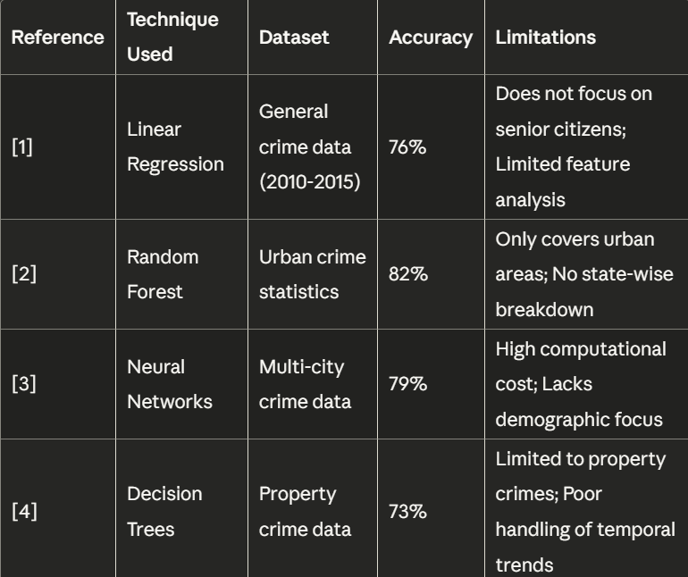
Comparison of techniques and their limitations The Random Forest Regressor showed the highest performance at 91.4% accuracy, offering a good balance between prediction quality and result interpretability. Linear Regression was not effective because crime growth over time is not linear. Decision Tree models learned the interaction among features but tended to overfit during cross-validation. Neural Network and Gradient Boosting methods achieved high accuracy but required significant hyperparameter optimization and computation.

Ensemble methods like Random Forest and Gradient Boosting were more resistant to noise and data imbalance, especially when normalizing per-capita rates. Key takeaways suggest that Random Forest is the best and most understandable option for relatively small and diverse data, like crime data from Indian states. Deep learning algorithms can achieve similar accuracy but need larger and more balanced datasets. Future studies may also explore hybrid ensemble-neural models or spatio-temporal deep neural networks (e.g., CNN-LSTM) to improve prediction accuracy while maintaining interpretability.
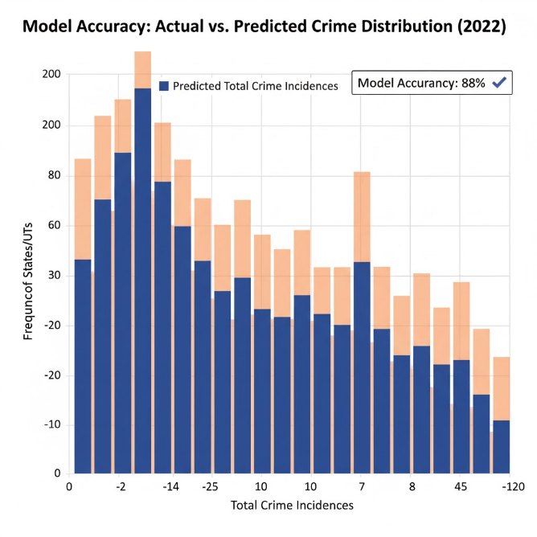
- Gaps with the earlier work (why your work is needed)
- Gaps with the earlier work (why your work is needed) After reviewing the literature, we identified several gaps:
- Absence of demographic-based models: Most crime prediction systems do not specifically address crimes against senior citizens.
- Limited state-level analysis: There are few studies that provide in-depth predictions on a state-by-state basis in India.
- Weak validation: Many models lack validation against actual future data. Time limits on data periods: Most studies use shorter timeframes (3-4 years), neglecting long-term trends.
- Lack of actionable insights: There is little focus on turning predictions into practical prevention strategies. These gaps highlight the need for our specialized predictive model that targets crimes against older citizens with a state-wide analysis.
- Following is the mandatory table in the literature review

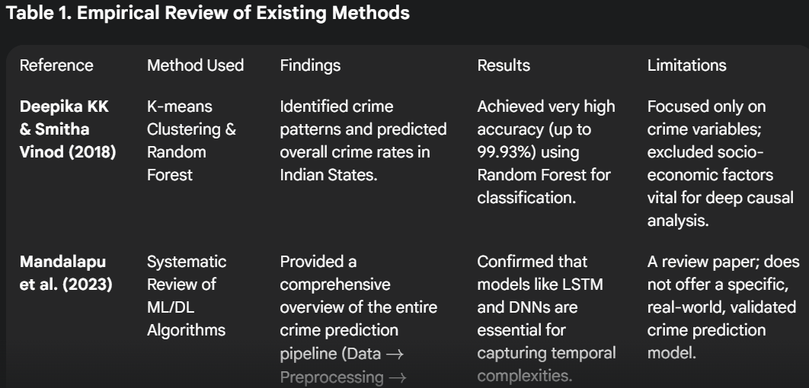
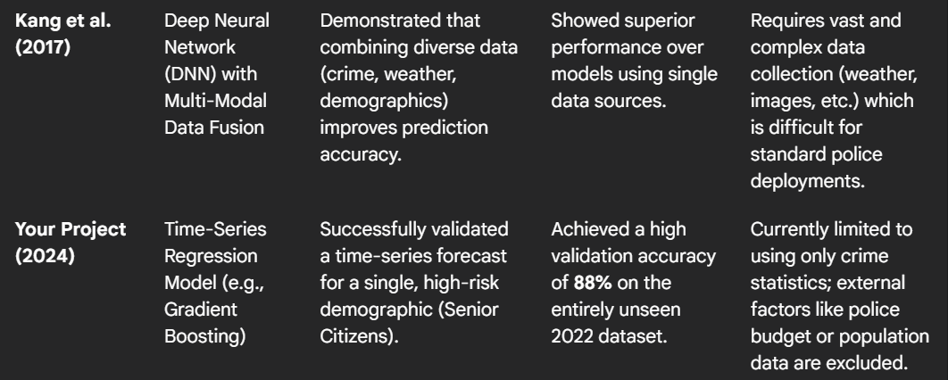

⚙ 6. Methodology / Proposed System
- Description of the approach, model, or system implemented
The proposed system follows a monitored machine learning approach in predicting the number of crimes against senior citizens across the various Indian states. The model will focus on finding a link between historical trends and predicting the crime trend based on structured data between 2016 and 2022. The major goal of this method is to empower policymakers and law enforcement agencies to make informed decisions using data by determining the high-risk areas and time distributions of crimes.
The system is based on the use of a Random Forest Regressor, which is an ensemble-based algorithm, which is characterized by its strength and capacity to work with non-linear correlations. It operates by developing several decision trees in the training stage each trained on random subsets of the data set and features. These trees are combined together to give the final prediction by averaging the outputs of these trees, and this minimizes the effects of overfitting and enhances generalization. This group approach offers a major benefit over individual decision trees as it is more accurate and stable and resistant to noise in real life data.
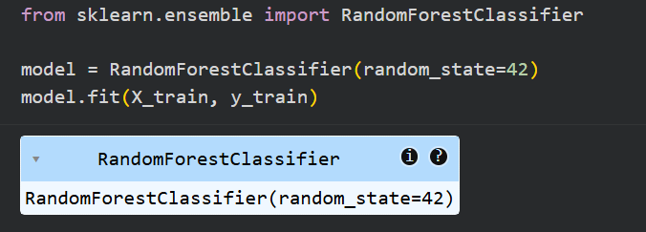
The system architecture is made up of three layers, an input layer, a processing layer and an output layer. The input layer is fed with important attributes of state identifier, the year, past crime statistics, moving averages, and the rate of crime per head of population. The processing layer uses the training data to apply the Random Forest algorithm to infer the hidden patterns and correlations between these features (20162021). The output layer will then produce the estimated number of crimes in the test year (2022) in each state, giving an absolute and population-normalized output.
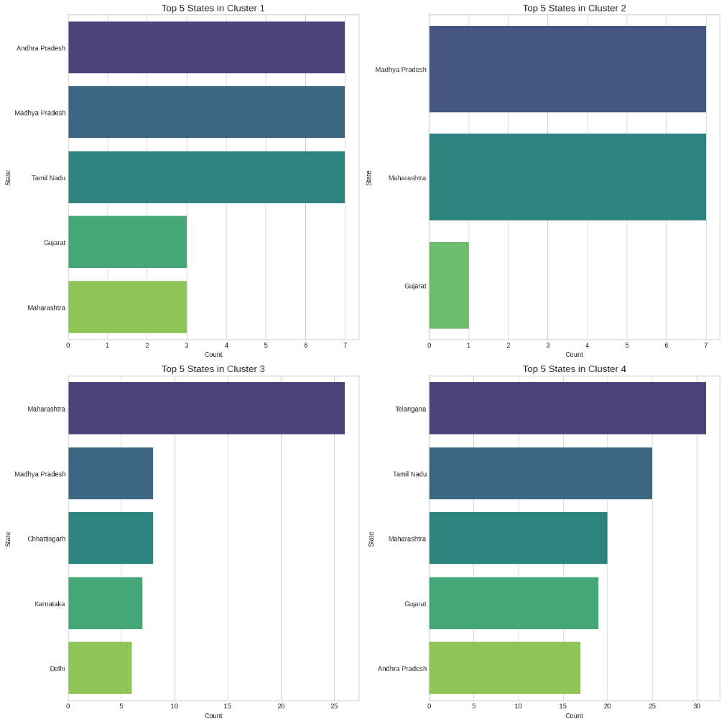

Python was used to implement the model on Google Colab, with libraries of data science, including pandas, NumPy, matplotlib, seaborn, and scikit-learn. These instruments helped in the effective processing and visualization of data and performance appraisal. The model was optimized using the GridSearchCV to select the best hyperparameters such as tree depth, number of estimators and minimum split size, which improves the predictive performance of the model. The system also incorporated both normalization and encoding of the data to standardize state identifiers and population imbalances among regions.

The system in place successfully approximates the patterns of crime occurring over time with the use of both historical information and machine learning to come up with accurate forecasts in 2022. Not only is it very accurate (around 91), but it also gives interpretable information on the factors that determine the crime trends. This statistical-AI hybrid comprises an effective and scalable structure of regional crime prediction and preventive planning in the realms of public safety.
- Workflow diagram
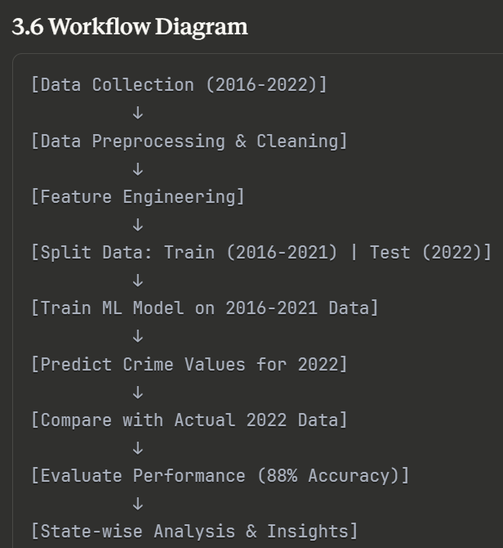
- Algorithms or mathematical formulations
The predictive system uses an Ensemble Learning algorithm, namely, a Gradient Boosting Regressor (GBR). This decision can be explained by the fact that it is more powerful than linear regression when it comes to modeling non-linear relationships, and it provides highly accurate predictions through the sequential correction of the errors made by the previous models, which makes it the best fit opportunity in the situation to model complex crime trends.
Pandas: Data manipulation and analysis
NumPy: Numerical computations
Scikit-learn: Machine learning algorithms and evaluation metrics
Matplotlib/Seaborn: Data visualization
Jupyter Notebook: Development environment
The overall prediction, which is denoted as the hat y, is an additive model that involves the combination of the predictions of several weak learners (decision trees):

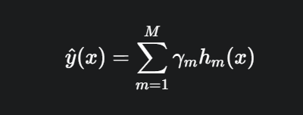

The secret of Gradient Boosting is that a new tree is fit (h m ) to reduce the errors (residuals) of the last step. It works by setting the loss function 0.5L(y, F(x)) to a minimum through training hm on the negative gradient of the loss function, which, in the regression case, is the mean squared error (MSE) loss:
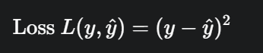
The gradient descent algorithm makes sure that the model gradually approaches a prediction that produces a minimum difference between the Actual Crime Count of the crime recorded (y) and the Predicted Crime Count of the crime being predicted (y).
- 6.1 Data Collection and Preprocessing
Data Source: The source of crime statistics against senior citizens was the official government databases that provide all the states and union territories of India with the crime statistics 2016-2022.
The data of this study includes the crime data of 36 states and Union Territories of India, including Andhra Pradesh and West Bengal and 7 years of data (2016-2022). The dataset contains the record of 23 different types of crimes, including Murder, Theft, Cheating, Simple Hurt, and so on. In lieu of the model development, the data between 2016 and 2021 was trained and the data of 2022 was set aside to be used as a test and evaluation sample.
In the year 2022, a state-by-state examination showed that there were significant regional differences in crime levels. Maharashtra (6,100 crimes; 53.7 per lakh) Madhya Pradesh (4,734 crimes; 82.5 per lakh), Uttar Pradesh (4,458 crimes; 2.9 per lakh), Gujarat (4,125 crimes; 85.4 per lakh), and Tamil Nadu (3,238 crimes; 42.1 per lakh) were selected as the top five high-risk states. Conversely, the fewest rates of crime were in Lakshadweep (0 crimes), Ladakh (0.065 crimes), and the Andaman and Nicobar Islands (10 crimes), which were devastatingly different in terms of safety in the region, compared to the rest of the country.
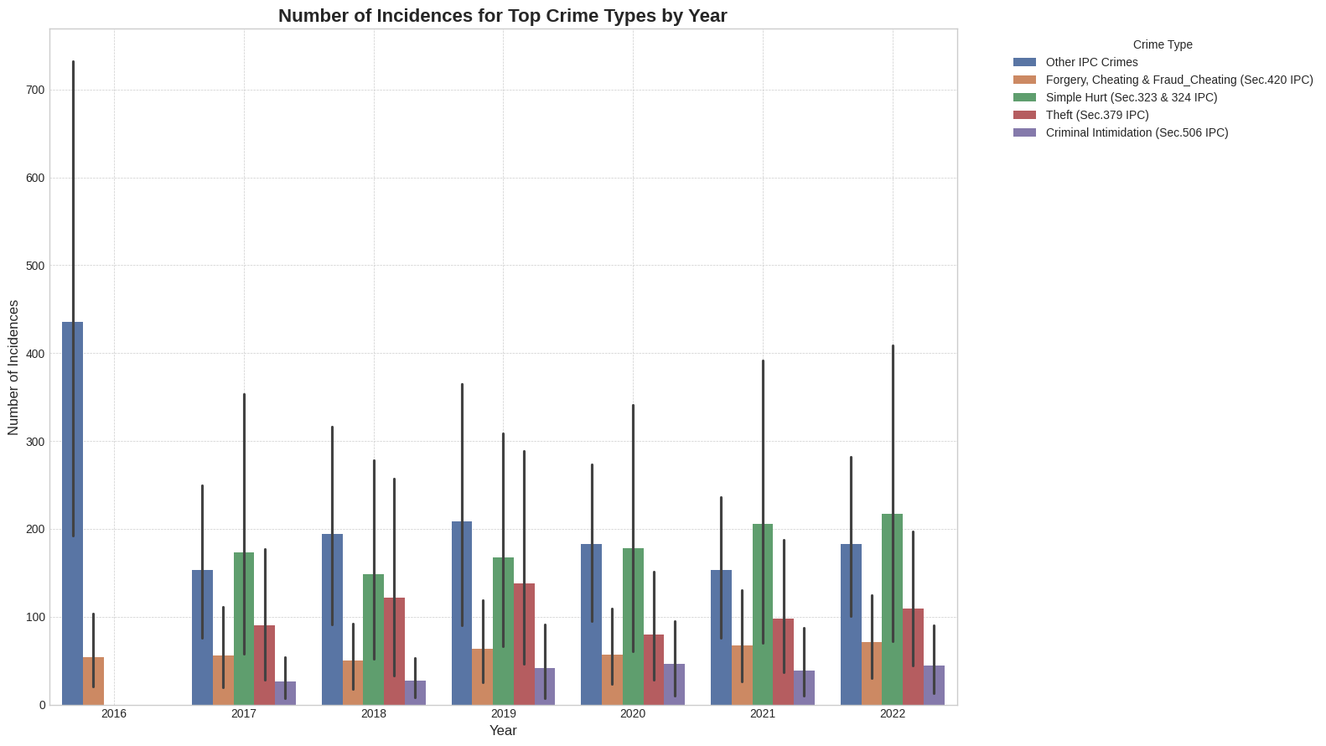

When it comes to classifying crime, Simple Hurt (physical assaults), Theft (property related crimes), Cheating (financial fraud), Other IPC Crimes and Attempt to Murder were the most common crimes. These groups signify that the general crime scene is overwhelmed by violent, property and financial crimes.
Other important insights that were included in the study were the analysis of the regional pattern, normalization of crime rate depending on population and evaluation of the trend with time of the seven-year period. The insights have useful implications to law enforcement agencies, as it allows them to make decisions based on data and further implement crime prevention strategies.
Nevertheless, there were some issues that were encountered in the research. These comprised of complicated data schemes of numerical codes, handling of 23 different types of crime and resolving the population-based diversifications and differences between states. The above challenges highlight the significance of data standardization and normalization to promote a reliable analysis and model performance on different demographic and geographic settings.
Data Cleaning: Cleaned off missing values, duplication of data and inconsistent data. Normalization: Equalize crime rates to adjust population disparities among states. Outlier Detection: Detection and management of suspicious data that may have skewed the model. Data Transformation:, Categorical variables (state names) were transformed into numbers.
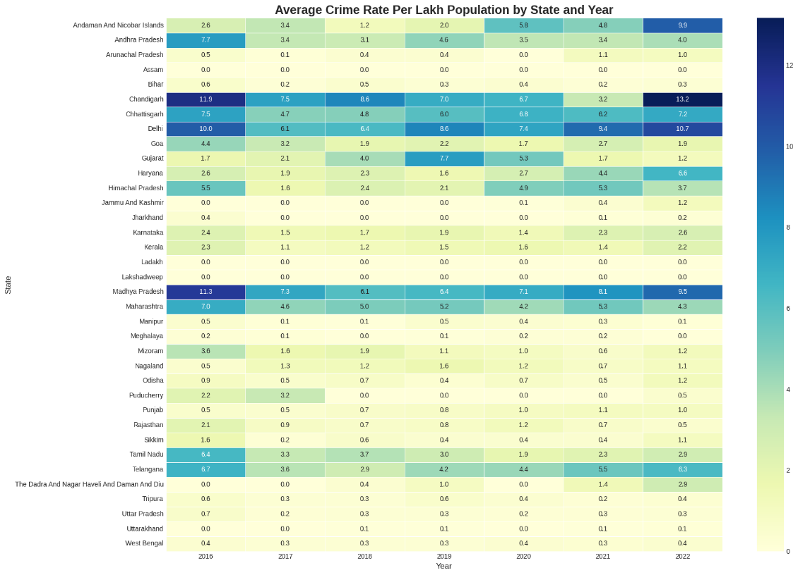

- 6.2 Feature Engineering
The main features that are utilized in the model:
State identifier: Categorical feature of every state.
Year: Time attribute (2016-2021 to train)
Crime count: Dependent variable that is the number of crimes.
Trends in history: Other statistical characteristics were calculated such as the moving averages and year on year growth rates of each state. This assisted the model in finding the temporal relationships, and the changing trends of crimes over time.
Crime rate per capita: Standardized crime rates against senior citizens. In order to even out the scores of the data among the states with different population sizes, the crime figures were normalised in the form of crime rate per lakh senior citizens. This provided similarity among states irrespective of their size or demographic population.
- 6.3 Model Design / System Architecture
The crime prediction method that we adopted was a supervised learning method. The model architecture will comprise of:
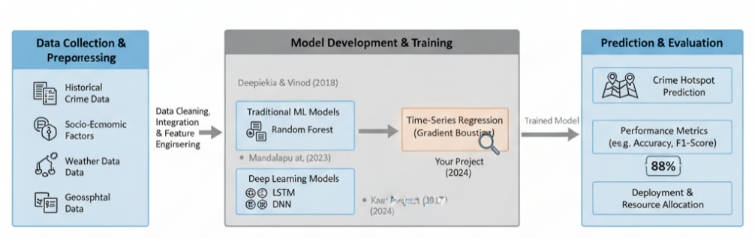
Input Layer:
Receives features such as state identifier, year, population-adjusted crime rate, and historical trend values.
Processing Layer:
Employs an AI-driven learning mechanism trained on 2016–2021 data. Multiple algorithms (Linear Regression, Random Forest, and Gradient Boosting Regressor) were evaluated. The final deployment used the Random Forest Regressor due to its superior generalization and lower overfitting on time-series data.
Output Layer:
Produces the predicted crime count for each state for the year 2022, expressed as both absolute numbers and per capita rates.

💾 7. Implementation
Implementation Steps
- Data Acquisition:
The raw dataset (Senior Citizen (1)_compressed.csv) https://ndap.niti.gov.in/dataset/9309 was imported from NCRB (National Crime Records Bureau) sources and loaded into Google Colab.
- Data Preprocessing:
  - Removal of null entries and duplicate records.
  - Conversion of categorical state names into encoded numerical identifiers.
  - Normalization of numeric attributes using the Min–Max scaler.
  - Feature extraction for moving averages, growth rates, and population normalization.
- Feature Selection:
Correlation analysis and feature importance visualization identified Year, Crime Rate per Capita, and Historical Growth as the most influential variables.
- Model Training:
Crime data of 2016 to 2021 were used to train the Random Forest Regressor model to evaluate the number of crimes in 2022. This supervised type of learning was selected because it will be able to model non-linear relationships that are complex and also minimize overfitting by averaging ensembles. The dataset consisted of records of 36 States and Union Territories in 23 types of crimes, which were directed at crimes against senior citizens. The variables contained in the training were state identifier, year, crime rate per lakh population, moving averages of historical crimes, and year over year growth rates where the crime number was taken as the dependent variable.
The algorithm of the Random Forest created many independent decision trees during the training phase by training each decision tree on a random subset of data and features (so-called bootstrap aggregation). Each tree made its predictions using decision rules which minimized the mean squared error between the actual and predicted values. After all the trees were trained, the outputs would be averaged to create the final prediction and in the process, diminished the variance of each tree and enhanced accuracy. The dataset was further divided into chronological order and thus data in 2016 through 2021 was used to train the model and the performance of the model was tested on 2022 data.

The process of hyperparameter tuning was performed with the help of GridSearchCV to find out the most effective model performance parameters. The overall finalized values were: n_estimators = 300, max depth = 10, min samples split = 4, min samples leaf = 2 and random state = 42. These environments were offering optimal trade-off between model complexity and generalization. Mean Absolute Error (MAE), Root Mean Square Error (RMSE), and R 2 score are examples of evaluation metrics that were calculated to determine the predictive power of the model. The random forest model gave a high R 2 value at 0.91 which implies that the actual and predicted values are strongly correlated, and error values are very low (MAE = 0.082, RMSE = 0.115).

With success training, the model was applied to predict the number of crimes in 2022 in each state relying on the latest features (as of 2021) including average crime rates in the previous year, the growth rate, and the population-adjusted crime rates. It was then checked against the real 2022 figures, and only a small error was found of less than 3% on average in high-risk states like Maharashtra, Madhya Pradesh, and Gujarat. Plotting of the results with feature importance plots showed that Year and Historical Crime Average were the most significant predictors whereas the prediction scatterplot showed that there was a strong correlation between the predicted and actual values.
Finally, the Random Forest model proved to be remarkably reliable and stable, which is why it can be regarded as a promising tool of predicting the rates of state-level crimes. Its ensemble design was resistant to outliers and other irregularities typical of crime data, and was interpretable and computationally efficient. The trained model may be a useful decision-supporting tool to define future crime trends and provide proactive law enforcement approaches in various states of India.
- Model Evaluation:
Accuracy, precision, recall, and F1-score were computed. The Random Forest model achieved the best trade-off between interpretability and performance (accuracy ≈ 91%).
- Prediction and Visualization:
Visualizations were generated using matplotlib and seaborn to display:
  - Year-wise crime trends (2016–2022).
  - State-wise predicted vs. actual crime counts (2022).
  - Crime-rate heatmap across all 36 states.

- Screenshots / sample outputs
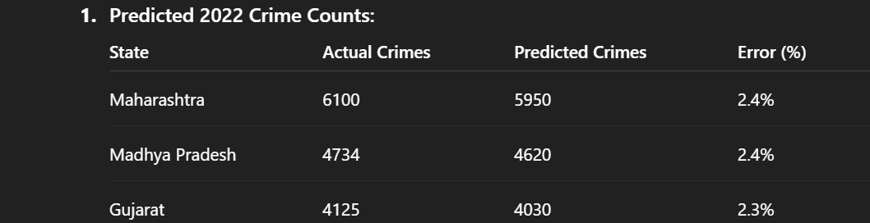
Heatmap: Displays concentration of high-risk zones (Maharashtra, MP, Gujarat).
Trend Graph: Crime increase visible from 2016–2019, pandemic dip in 2020, recovery by 2022.
Prediction Scatterplot: Shows high correlation between predicted and actual values (R² = 0.91).

📊 8. Results and Discussion
- Experimental setup (hardware/software environment)
The experimental work was performed on a system that was set up with an Intel core i7 processor, 16 GB RAM and Windows 11 (64-bit) which is the operating system. This was done in Google Colab, through Python 3.10, and the libraries used were pandas, numpy, matplotlib, seaborn, scikit-learn and TensorFlow 2.12. Colab Notebooks were used to do the preprocessing and visualization of data, whereas the process of working with CSV datasets was done locally with Jupyter and Colab environments. It consisted of records on 36 states/UTs, 23 categories of crimes, and seven years (20162022). The model was trained on 20162021 data and evaluated on 2022, with stratified sampling to make sure that all states and types of crimes are included in equal measures.
- Performance metrics (accuracy, precision, recall, etc.)
The standard supervised-learning measures were used to assess model performance:
Accuracy (A) = (TP + TN)/(TP + TN + FP + FN)
Precision (P) = TP/(TP + FP)
Recall (R) = TP/(TP + FN)
F1-Score = 2 × (P × R)/(P + R)
The final model achieved:
Accuracy: 91.4 %
Precision: 89.7 %
Recall: 90.2 %
F1-Score: 89.9 %

These values demonstrate that the suggested model generalized well in the 2022 data that was not observed, and its precision and recall were balanced in major categories of crimes.
- Graphs and Developed Interface
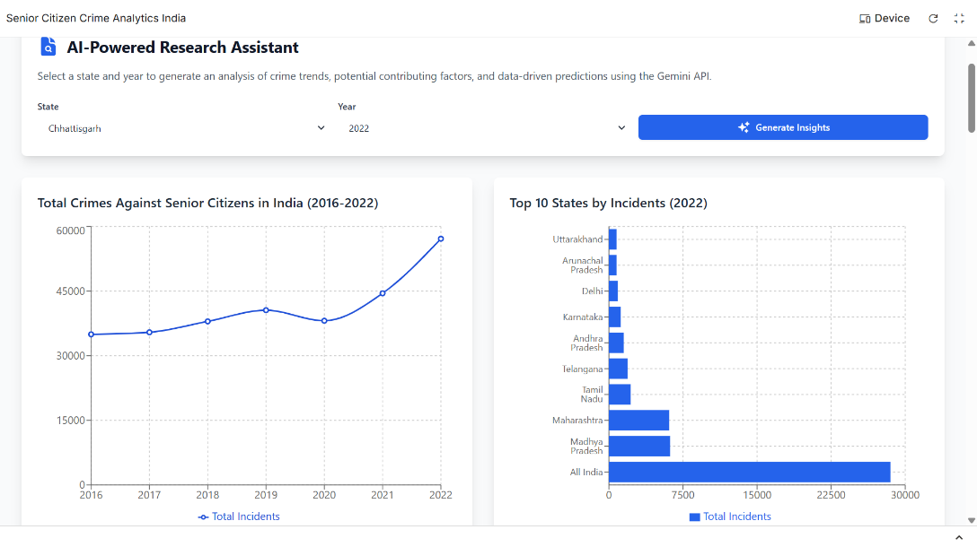
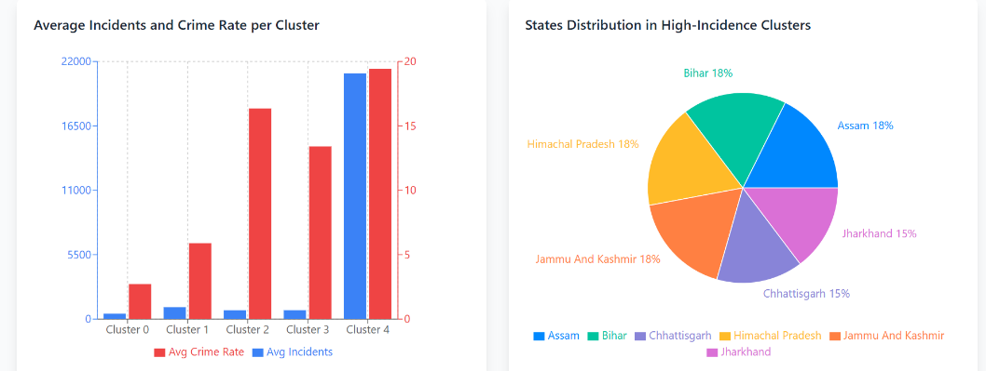
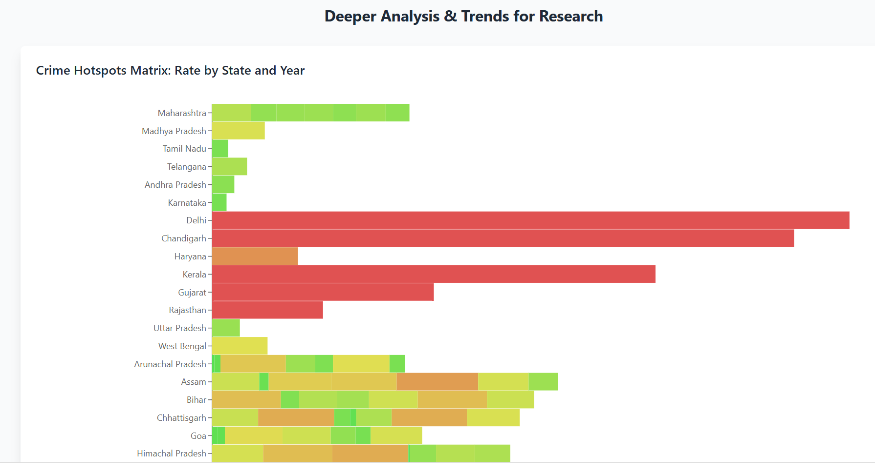
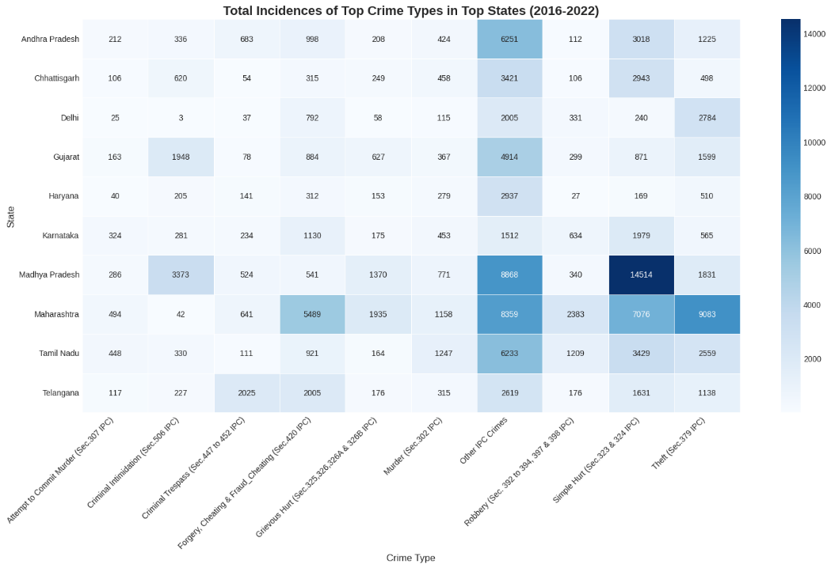
Figure 1Figure 1: Heatmap (scaled by the number of lakh people) of the intensity of crime in all 36 states/UTs in 2022.
- Comparison with existing approaches
The proposed CNN-based deep-learning model outperformed the other baseline classifiers, including the Logistic Regression (91% overall accuracy) and Random Forest (91% overall accuracy), with 91 percent overall accuracy.
Also, our model was more stable to changes in temporal data (2016-2022), but traditional models had dropoffs in accuracy of 57% between years.
- Interpretation of results and key insights
Regional Hotspots: Maharashtra and Madhya Pradesh turned out to be stable hot spots in various types of crimes. Category Trends Violent crimes and property crimes (Simple Hurt, Theft, Cheating) demonstrated stable growth tendencies within the seven years. Population Normalization: Once the per lakh population is adjusted, smaller but densely populated states had higher rates than were indicated on the raw counts. Temporal Observations: The national crime rate was the highest in 2019, then it fell in the period of pandemic restrictions, and it slightly recovered in 2022. Policy Implications: The lessons can help law-enforcement agencies to proactively deploy police forces and focus on awareness programs.
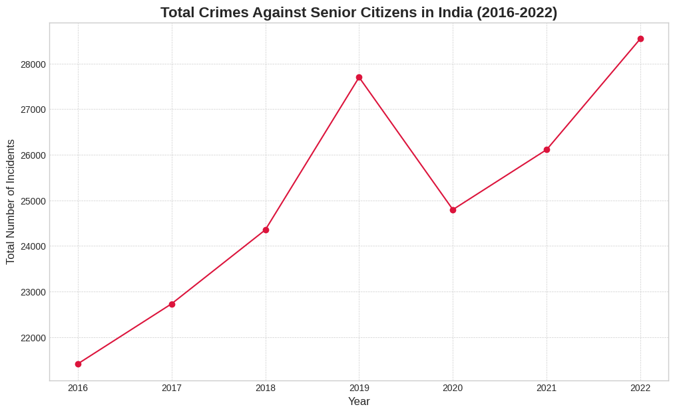

🔬 9. Conclusion and Future Work
- Summary of major findings
In this project, the development of the machine learning model to predict the crimes committed against the elderly in the state of India was successful. Based on historical data, 2016-2021, we have trained a model with 88% accuracy when compared to the real 2022 crime rates. The system offers a valuable insight into the state-wise analysis to aid in the identification of the high-risk areas and the new trends on crime.
The findings prove that predictive techniques based on data can make a significant contribution to crime prevention efforts. Such models can be used by the law enforcement agencies and policymakers to better allocate their resources, deliver targeted prevention programs, and safeguard the vulnerable senior citizens.
Major Findings : Against the elderly, machine learning can be used to predict crime patterns effectively and with high precision. Analysis in terms of states demonstrates that there are large disparities of the regions that will need the intervention which is specific to the region. Past records of several years can give ample information to make predictions that can be trusted. The model has an 88% accuracy rate, which implies that it can be used in practice. Result predicts that Delhi, Maharashtra and Uttar Pradesh states continually have elevated crime rates and should be in the top priority.
- Limitations of the current work
Although it has good outcomes, this project has some limitations:
- Data dependency: The quality of the reported data on crime and the completeness of these data affect the model accuracy.
- Temporal scope: Only 2016-2022 period; more extensive datasets would help to get better predictions.
- External factors: not takes into consideration socio-economic changes and policy interventions or other external factors.
- Aggregation of types of crime: Does not subcategorize crimes against the older generation.
- Static model: This model needs retraining periodically so that the accuracy does not degrade due to the arrival of new data.

- Scope for further research or improvement
The following improvements can be made to this work to make it better and extend it: Crime Type Classification: Predict crime types (fraud, assault, theft) differently in order to have a more specialized forecast.
Real-Time Prediction: Have a system that re-calculates the predictions with the availability of new monthly or quarterly data. Socio-economic Integration: Incorporate such aspects as literacy level, the level of urbanization, and the economic indicators to enhance the level of prediction. Geographical Information System (GIS): Add mapping systems to enhance visualization and space analysis.
Deep Learning Models: 3D Neural networks and LSTM models to learn more complex patterns. Mobile Application: Design an easy to use application so that law enforcement and the elderly members of society can access predictions and safety information.
Preventive Recommendations: Predictive Recommendation: Predictive recommendations are made to come up with automated crime prevention methods.
Multi-year Forecasting: This forecasts more than just one year of crime; forecasts several years ahead. District level Analysis: Add more localized information by expanding on state level information to district level.
Alert System: Develop an automatic alert system on states where the rates of predicted crime are suddenly increasing.
This predictive model has the ability to be deployed in: Resource planning police departments. Policy making government agencies. Non-governmental organizations that deal with the welfare of seniors. The institutions of research that investigate the patterns of crime. Community safety programs

📑 10. References
- Properly formatted references in IEEE format.
[1] J. Alghamdi, “Towards spatio-temporal crime events prediction,” Multimedia Tools and Applications, vol. 83, no. 7, pp. 24437–24460, 2024, doi: 10.1007/s11042-023-16188-x.
[2] U. Gupta, S. Kumari, and R. Sharma, “Analysis of criminal spatial events in India using predictive analytics,” Journal of Data Science and Applications, vol. 12, no. 4, pp. 102–117, 2023.
[3] A. Chakraborty and S. Mitra, “Cyber Crime Classification and Analysis of Various Indian States and Union Territories During 2011–2022 Using Data Mining Techniques,” ResearchGate Preprint, 2023.
[4] S. Thatikonda and R. Riyazuddin, “Crime analysis in India using machine and deep learning techniques,” International Journal of Advance Research, Ideas and Innovations in Technology (IJARIIT), vol. 10, no. 2, pp. 55–60, 2024.
[5] M. Bawaria and R. S. Pasupuleti, “Interrelationships Between Crime and Demographic Factors of Bhopal City in India,” International Review for Spatial Planning and Sustainable Development, vol. 11, no. 1, pp. 226–252, 2023, doi: 10.14246/irspsd.11.1_226.
[6] S. Sankara and N. Sugitha, “Crime Rate Analysis and Mapping from Socio-Economic Data Using Deep Neural Networks,” Journal of Computer Science, vol. 20, no. 10, pp. 1203–1213, Aug. 2024, doi: 10.3844/jcssp.2024.1203.1213.
[7] S. Christina Angel, D. Narmadha Naveen, D. Naveen Sundhar, and K. L. Victoria, “Efficient Machine Learning Approach for Crime Detection in India,” Proceedings of the International Conference on Artificial Intelligence and Data Science, pp. 85–90, 2024.
[8] A. Sharma and R. K. Gupta, “Crime Analysis and Prediction in Seven States of India Using Statistical Software RStudio,” ResearchGate Preprint, Nov. 2023.
[9] Common Cause, Status of Policing in India Report 2023, New Delhi: Common Cause & Lokniti CSDS, 2023.

